Cloud Gateway

☁️ What is a Cloud Gateway?
# Source: AI Source: Provided by: [Data Path: Persons Table -> ID Column: 1, Name_En Column: Motasem Essam] -> From: [ChatGPT] on [12/18/2025]
A Cloud Gateway is a network service or device that acts as a bridge between on-premises infrastructure and cloud environments. It enables secure, seamless communication between local data centers, private networks, or users and public or hybrid cloud platforms (like AWS, Azure, or Google Cloud).
✅ Think of a Cloud Gateway as the "entry point" that connects your private infrastructure to cloud resources, allowing secure access and data exchange.

🔧 What Does a Cloud Gateway Do?
# Source: AI Source: Provided by: [Data Path: Persons Table -> ID Column: 1, Name_En Column: Motasem Essam] -> From: [ChatGPT] on [12/18/2025]
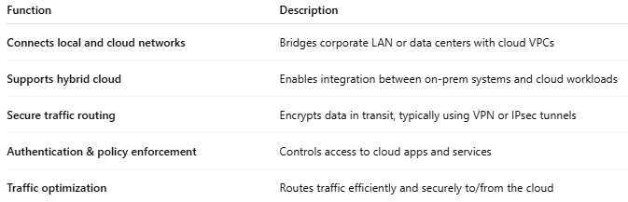

Function | Description
Connects local and cloud networks | Bridges corporate LAN or data centers with cloud VPCs
Supports hybrid cloud | Enables integration between on-prem systems and cloud workloads
Secure traffic routing | Encrypts data in transit, typically using VPN or IPsec tunnels
Authentication & policy enforcement | Controls access to cloud apps and services
Traffic optimization | Routes traffic efficiently and securely to/from the cloud

🧱 Where It's Used
# Source: AI Source: Provided by: [Data Path: Persons Table -> ID Column: 1, Name_En Column: Motasem Essam] -> From: [ChatGPT] on [12/18/2025]
- Hybrid Cloud Networking
  - Connects your on-prem infrastructure to cloud services
- Cloud Storage Access
  - Enables on-prem apps to access or sync with cloud storage
- Secure SaaS Access
  - Acts as a gateway to control access to SaaS apps like Office 365, Salesforce, etc.
- Cloud Migration
  - Helps move workloads securely and efficiently to the cloud

☁️ Common Cloud Gateway Examples
# Source: AI Source: Provided by: [Data Path: Persons Table -> ID Column: 1, Name_En Column: Motasem Essam] -> From: [ChatGPT] on [12/18/2025]
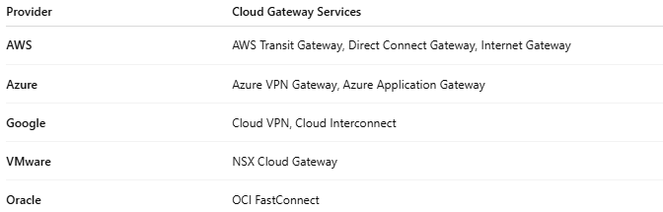

Provider | Cloud Gateway Services
AWS | AWS Transit Gateway, Direct Connect Gateway, Internet Gateway
Azure | Azure VPN Gateway, Azure Application Gateway
Google | Cloud VPN, Cloud Interconnect
VMware | NSX Cloud Gateway
Oracle | OCI FastConnect

🔐 Security Features
# Source: AI Source: Provided by: [Data Path: Persons Table -> ID Column: 1, Name_En Column: Motasem Essam] -> From: [ChatGPT] on [12/18/2025]
- 🔒 VPN support (IPsec, SSL, IKEv2)
- 🔐 Firewall integration
- ✅ Access control policies
- 📊 Traffic monitoring & logging

✅ Advantages
# Source: AI Source: Provided by: [Data Path: Persons Table -> ID Column: 1, Name_En Column: Motasem Essam] -> From: [ChatGPT] on [12/18/2025]
- ✅ Seamlessly connects local and cloud environments
- ✅ Enhances cloud performance and reliability
- ✅ Adds security and control over cloud access
- ✅ Supports scalable hybrid architecture
- ✅ Reduces latency with optimized routing

❌ Disadvantages
# Source: AI Source: Provided by: [Data Path: Persons Table -> ID Column: 1, Name_En Column: Motasem Essam] -> From: [ChatGPT] on [12/18/2025]
- ❌ Requires proper network design
- ❌ Can add latency if misconfigured
- ❌ May incur extra costs (bandwidth, gateway instance pricing)
- ❌ Needs expertise to manage securely

🧠 Cloud Gateway vs Internet Gateway vs VPN Gateway
# Source: AI Source: Provided by: [Data Path: Persons Table -> ID Column: 1, Name_En Column: Motasem Essam] -> From: [ChatGPT] on [12/18/2025]
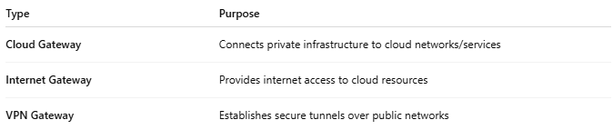

Type | Purpose
Cloud Gateway | Connects private infrastructure to cloud networks/services
Internet Gateway | Provides internet access to cloud resources
VPN Gateway | Establishes secure tunnels over public networks

📌 Summary
# Source: AI Source: Provided by: [Data Path: Persons Table -> ID Column: 1, Name_En Column: Motasem Essam] -> From: [ChatGPT] on [12/18/2025]
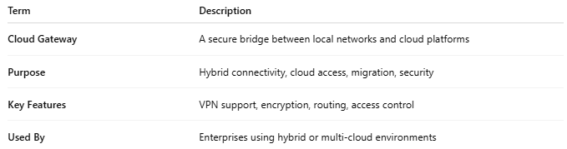

Term | Description
Cloud Gateway | A secure bridge between local networks and cloud platforms
Purpose | Hybrid connectivity, cloud access, migration, security
Key Features | VPN support, encryption, routing, access control
Used By | Enterprises using hybrid or multi-cloud environments

